NOMOR 1

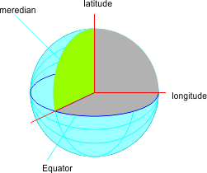

- latitude : 0'

- longitude : 0'

it is located in round of ghana

the republic of indonesia is located on the geografi coordinates of :

latitude : 6.1750'

longitude : 106.8283'